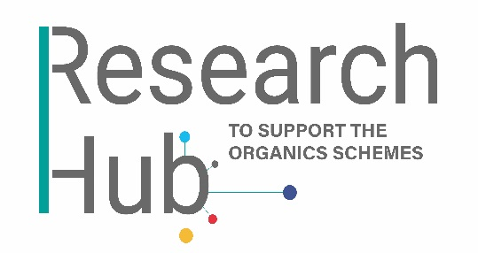
Research Proposal Submission Form

We recognise that this project proposal plan may not be definitive but REAL will support you in completing your proposal. Shortlisted projects will be asked to provide a final revised plan. Please contact Stephen Nortcliff, advisor to the Research Hub, using s.nortcliff@reading.ac.uk, if you require assistance in completing this form.
- Your details:

Title(s)
First name(s)
Surnames(s)
Email(s)
Telephone(s)
Organisation(s)

- About the project:

Project title (max. 25 words)
Description of the proposed work (max. 250 words)
Brief statement of objectives, methodology and outcomes:
- Objective(s) (max. 60 words)
- Methodology (max. 60 words)
- Aim(s)/outcome(s) (max. 60 words)
Perceived relevance to the Compost Certification Scheme (CCS) and/or Biofertiliser Certification Scheme (BCS):
CCS BCS CCS & BCS
Benefit(s) for relevant schemes:

Please send your completed form to Olivia Furssedonn (Research Hub Manager) using olivia@realschemes.org.uk. You will receive an email from REAL to confirm safe receipt of your proposal document.

